Support your local library!

Friends of Moorland Road Community Library

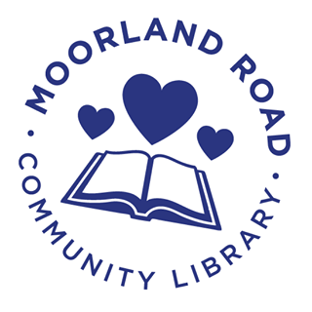

Moorland Road Community Library was saved from closure in 2019, but it costs £6,000 a year to run
Can you help……..?

Did you know …….?
- The library is a Registered Charity

- Library services are provided by a group of local volunteers

- The library is open for 17 hours a week, 51 weeks of the year

- We have around 5000 books on our shelves, and you can reserve books from anywhere in the LibrariesWest region

- The council owns the library building, but we are responsible for all running costs, including heating, lighting, internet, insurance and IT

Can you help us to keep this important community facility open for the benefit of all?
You can do this by becoming a Friend of the library and making a regular monthly donation.
As a Friend you will receive:
- A twice-yearly newsletter bringing you up to date
- An invitation to our Autumn/Winter gathering
We would like to suggest a donation of £5 per month (although you are free to choose a different amount) paid by standing order. This method of payment means we are not handling cash or cheques in the library and that you are in control of your donation.
To set up your donation please use our bank details as follows:
Account Name: Moorland Road Community Library (Bath)
Sort Code: 30-90-89 Account Number 39612068

I wish to become a Friend of Moorland Road Community Library
Title
First Name
Last Name
Address
Post Code
Email address

I am happy to be contacted about library activities
Gift Aid
You can boost your donation to the library by 25p of Gift Aid for every £1.00 you donate. Gift Aid is reclaimed by the charity from the tax you pay in the current tax year. Your address is needed to identify you as a current UK taxpayer.
I am a UK taxpayer and understand that if I pay less income tax and/or capital gains tax than the amount of gift aid claimed on all my donations in the tax year, it is my responsibility to pay any difference.

Signed …………………………………………………………………
Date…………………………………….………………………………
Please drop your completed form into the library for the Trustees or email it to moorlandroadcommunitylibrary@gmail.com

